14th July 2017

Parents/Guardians
Of TQEA Students

Dear Parents/Guardians

Last day of term arrangements and student fete

On Friday 21st July we will be having a series of events across the day to celebrate our achievements this year and recognise the hard work put in by the students.

The day will be non-school uniform (as requested by the students) and there will be a £1 donation to charity. The chosen charity is the Birmingham Children’s Hospital, selected for the fantastic work it has done to support a number of our students in some very difficult times during the last year. Again the chosen charity was selected by a group of students.

In the afternoon, we will be organising a village fete style event where students will be able to participate in some weird and wonderful activities. Most of these will be at no cost, however, at some there will be a 10p charge to raise additional funds for Birmingham Children’s Hospital.

All students will receive 5 hours of education provision, but due to the changes to the timing of the school day we will finish at 2.45pm instead of 3.05pm.

Buses will run at their usual time. Some taxis will collect earlier, please check (well in advance of the last day of term) to see whether yours will be picking them up at 2.45pm or the usual time. If you would like your student to stay in our dining room, supervised until our usual finish time on the day please let us know via email at info@tqea.org.uk.

Our latest newsletter will be coming home with students today, full of stories from this term for you to enjoy. Students are due back in school on Monday 4th September 2017 at 8.45am, in the meantime, we wish you all a wonderful summer break.

Yours sincerely

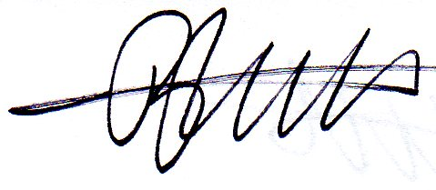

Mr Dan Watts
Principal

