4th April 2025

Dear Parents/Carers

May I please remind you that students are not permitted to use their mobile phones whilst in the academy. This is and has always been one of our school rules which all students are expected to adhere to.

We have recently seen an increase in students either ringing or texting parents during the school day for a variety of reasons, particularly if they feel unwell and request for parents to collect them from school. If your son/daughter feels unwell at school then they should report this to a member of staff or go to the reception at break or lunch times.

If a student does make contact home asking to be collected from school without going through the correct channels, this will be considered as misuse of their mobile phone whilst in school.

I would be grateful if you would remind your son/daughter of this and we will do the same.

Thank you for your continued support.

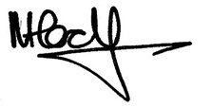

Mr N Harding

Principal