Dear Parent/Carer

Re: Calculators and Equipment

As part of their equipment list, all pupils are required to have a scientific calculator with them. Unfortunately, at the moment this is not the case for some of our students and this could impact on their learning and progress if not rectified as soon as possible, as they cannot access some of the key learning points without one. Please can you support us by ensuring your child has this vital piece of equipment and brings it to school with them.
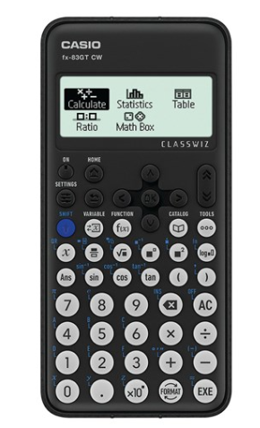
As such, the calculators we recommend for our 5-year curriculum (Casio classwizz fx-83GT ) are available to purchase in school for a discounted price of £10 (usually retail around £15). Please pay via MCAS app.

This can be found in most local supermarkets or on amazon (Calculator on Amazon- Click Here) the cost is around £12

The mathematics department welcomes the use of other models of scientific calculator, however, please note that both staff and students are more proficient in using the Casio model.

Thank you for your continued support in your child’s education.

Kind regards

Ms Shepherd
Associate Assistant Principal/ Head of Mathematics

